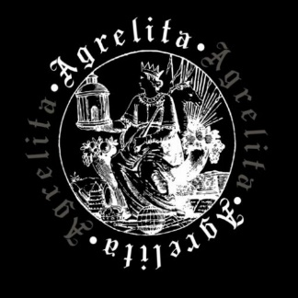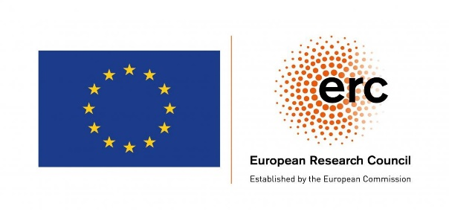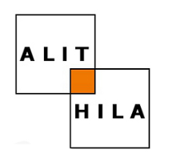

ERC Advanced Grant AGRELITA Project
The Reception of Ancient Greece in pre-modern French Literature and Illustrations of Manuscripts and Printed Books (1320-1550): How invented memories shaped the identity of European communities
Direction : Catherine Gaullier-Bougassas

The AGRELITA project ERC n° 101018777 was launched on October 1st 2021. It is a 5-year project (2021-2026) financed on an ERC Advanced Grant 2020 through the European Union’s Research and Innovation Programme Horizon 2020.

Workshops
New Translations and indirect Reception of Ancient Greece
(Texts and Images, 1300-1560)

Thursday, September 15th and Friday, September 16th 2022
Thursday, January 19th and Friday, January 20th 2023

The AGRELITA Project studies the reception of ancient Greece, exploring a corpus of French-language literary works produced from 1320 to the 1550s, as well as the images of their manuscripts and printed books. The development of direct translations from Greek to French begins only from the 1550s. From the beginning of the 14th Century until the middle of the 16th Century, French-language authors and artists who illustrate manuscripts and printed books of their works, with some exceptions, have no direct knowledge of Greek works. The knowledge about ancient Greece that they transmit and reinvent in their texts and in their illustrations is mediated by various filters. Their reception is indirect, based on previous textual and iconographic works, whose representations of ancient Greece are in fact the result of one or more receptions.
The workshops of September 2022 and January 2023 will be devoted to the analysis, through this corpus, of new translations and adaptations into French language from Latin works which convey the knowledge about ancient Greece, in several different forms. These Latin works adapted by 1300-1550s French authors are partly ancient and medieval works which are not translations, and partly translations or adaptations of Greek works, sometimes with several linguistic transfers from Greek. They take very diverse forms : from ancient texts (Ovid, Virgil, Boethius, Augustine, Darès, etc.) to Latin humanist translations of Greek works produced in Italy and in the Netherlands in the 15th and 16th Centuries, including original medieval Latin works (id est no translations, Vincent de Beauvais, Third Vatican Mythograph, Petrarch, Boccaccio, the author of Rudimentum novitiorum…), Latin translations from French (Guido delle Colonne) and Arabic-Latin and Arabic-Spanish-Latin translations (Aristotle, Dits moraux des philosophes…).
French-language authors thus inherit various previous receptions, which they appropriate and transform, so that they carry on the inventing process of representations of ancient Greece. As the manuscripts and printed books of these new translations often comprise a lot of illustrations, the artists present simultaneously visual translations, which are also based on various sources and previous receptions and show new images of ancient Greece. The question of the reception of ancient Greece will therefore be explored from another perspective than the one adopted until now and which consisted in studying the direct transmission of Greek works.
In the corpus of 1300-1550s French new translations / adaptations which relate to ancient Greece, its history, its heroes, its authors and their works, although they are not direct translations of Greek works, the multiple origins and the syncretism of the knowledge available to authors and artists will be explored, as well as the methods of their appropriation and transformation. We will analyze how this transmission of knowledge that already conduct various interpretations is above all matter of circulation and of creation of representations, and how the elaboration of images of ancient Greece contributes to inventing a cultural memory submitted to a large secular audience both through text and images.

The corpus of studies (texts and images in manuscripts and printed books) will be constituted as follows:
-the translations / adaptations into French of ancient Latin works and the images of ancient Greece that they convey, in particular the translations of the works of Ovid, of the Consolation of Philosophy by Boethius, of the City of God by Augustine, of De excidio Troiae historia by Darès the Phrygian…
-the retranslations into French of medieval Latin works that are translations from French, such as the ones of the Historia destructionis Troiae by Guido delle Colonne.
-the translations / adaptations into French of medieval Latin works that are not translations, and among the most widely distributed the ones written by Vincent de Beauvais (in the wake of Hélinand de Froidmont), Boccacio, Petrarch, but also many others texts; the images of ancient Greece that the mid-Latin works present and those that their adaptations in French transmit, accurate or not.
-the first indirect translations of Greek works, through Latin, Arabic-Latin or Arabic-Spanish-Latin translations (the French translations of the ethical and political works of Aristotle, the Dits moraux des philosophes...)
-from the 15th century, French translations of Greek works through Latin translations of humanists from Italy and the Netherlands. Particularly, the indirect translations of Xenophon, Plutarch, Thucydides, Diodorus of Sicily, Lucian, Homer, Euripides from the translations of Poggio Bracciolini, Leonardo Bruni, Lorenzo Valla, Guarino Veronese, Pier Candido Decembrio and Erasmus.
How do the humanist Latin translators of Greek works, and then the French translators of these Latin translations, present their translation initiatives? What images do they give (them and the illustrators of the manuscripts and printed books of their works) of Greek authors and works, and of ancient Greece in works that deal with its history and its characters? What changes are emerging in the reception of ancient Greece?
-the translations into other European vernaculars, during the 15th and 16th centuries, from Latin humanist translations of Greek works. Analyzing the new indirect translations, from Latin, in particular from Xenophon, Plutarch, Thucydides, Diodorus Sicile, Lucien, which are written in the other Romance languages ​​and in the English and Germanic languages, would make it possible to understand the commonalities as well as the differences of translation and reinterpretation in several European cultural fields, the various inflections given to Greek works and images from ancient Greece, the different uses of these translations, the different types of manuscripts and printed books, in their materiality and in their illustrations.

The papers will be published by Brepols publishers, in the "Research on Antiquity Receptions" series :
http://www.brepols.net/Pages/BrowseBySeries.aspx?TreeSeries=RRA

Travel and accommodation costs will be covered according to the terms of the University of Lille. Contact: Catherine Gaullier-Bougassas

Please submit a short abstract (title and a few lines of presentation) to catherine.bougassas@univ-lille.fr by December 15, 2021.

For more information about the ERC Agrelita Project, please see our academic Blog : https://agrelita.hypotheses.org/

